# **Delta Item Load Issue in Jobs Server –Exit Code 3.**

**Steps to Triage on Delta Item Load Issue : -**

**Step 1 :-**  
If we see Exit code 3 in logs which has heap dump issue and socket timeout issue.  
 🡪Move heap dumps from the server from **/opt/apps/IBM/WebSphere/CommerceServer80/bin/ to /opt/apps or/tmp/ for analysis.**

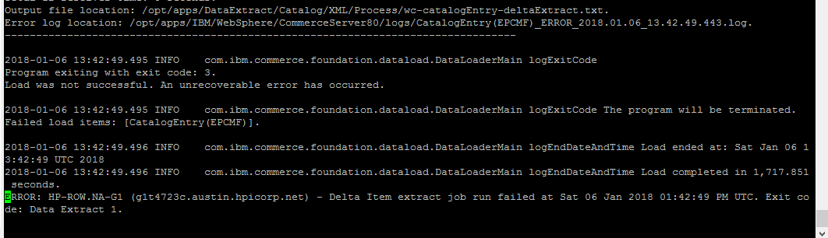

**Heap Dump Logs in HPDeltaExtract.log.20180106.1314**

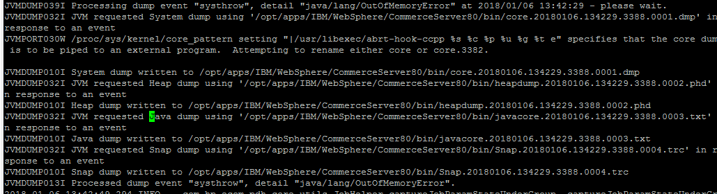

**/opt/apps/IBM/WebSphere/CommerceServer80/logs/CatalogEntry(EPCMF)_ERROR_2018.01.06_13.42.49.443.log**

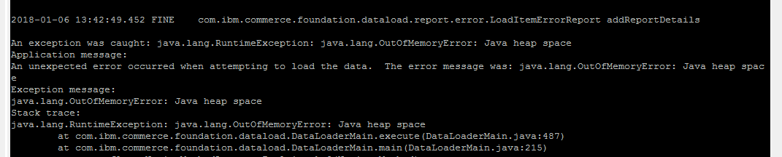

In case of heap dump in delta item load, please don’t retrigger the job.

**Step 2 :-**

Check the script has heap size defined correctly or request approval from manager , do needful changes and commit file in SVN.  
Location - **/opt/apps/IBM/WebSphere/CommerceServer80/bin/dataextract.sh**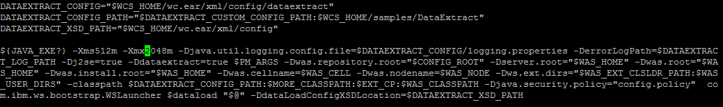

**$    
{JAVA_EXE?} -Xms256m -Xmx1024m  
To   
${JAVA_EXE?}     
-Xms512m -Xmx2048m (Currently present in Production)**

**Step 3 :** Updating using query **hp_batchjobruns In stager DB.**

We have to reset the params to original values [as in start of the job] before triggering

PFB the details on the same.

* Execute the query

**select * from hp_batchjobruns where job_id=1059 order by start_time desc;**

[Take the id of the run [49652], As it was triggered 2 times again rather than scheduled one, its showing 3 id’s]

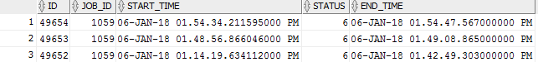

* select * from HP_BATCHJOBRUNSTATS where jobrun_id=49652;

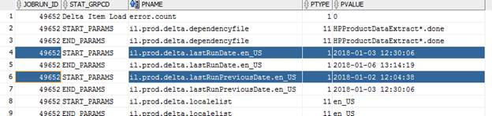

update hp_batchjobparams set pvalue='2018-01-03 12:30:06' where job_id='1059' and pname='il.prod.delta.lastRunDate.en_US';

commit;

update hp_batchjobparams set pvalue='2018-01-02 12:04:38' where job_id='1059' and pname='il.prod.delta.lastRunPreviousDate.en_US';

commit;